Rekonstruksi Sistem Informasi Akuntansi Organisasi Nirlaba Berbasis Web

(Studi Kasus GMIM Jemaat Bethesda Tatelu

**Ivonne Helena Putong** 1,a, Antonius P.G. Manginsela 2,b,*, and Joseph Nugraha Tangon 1,2,c

1a, 1c Accounting Department, Politeknik Negeri Manado

1b Electrical Engineering, Politeknik Negeri Manado

Kampus Buha, Mapanget, Manado 95252, Indonesia

e-mail: a [ivonnehelen@gmail.com](mailto:ivonnehelen@gmail.com) and b [antonpgm@gmail.com](mailto:antonpgm@gmail.com)

* Corresponding Author

**Abstract**

*One of the largest non-profit organizations in North Sulawesi is the Minahasa Evangelical Christian Church (GMIM). Although it’s not business-oriented, church administrators are required to make financial reports as an accountability to the congregation and donors. There are several obstacles in financial management. Financial management is held by the treasurer assisted by church employees who do not always have an accounting education background. Working as a treasurer not as a full-time employee but setting aside time from routine activities to manage church finances. So far, financial administration and reporting have been made manually using Microsoft Excel. As a result, processing time becomes longer, requires a lot of energy and has the potential for errors to occur.*

*This collaborative research aims to provide a solution by reconstructing the church's accounting information system and then making it in one application. The church's accounting system uses a cash basis, so this study covers the cash receipts and disbursements system. This research is included in the type of research and development (research and development), namely a research approach to produce a new product.*

*The church accounting information system is designed to follow the applicable rules, namely the 2021 GMIM Synod Church Administration and the GMIM Treasury Supervision and Governance Service Guidelines that 1,049 GMIM Congregants must obey. The results of the reconstruction are made in the Indah GMIM application to make it easier for users to generate church financial reports.*

*Faster processing time, reports more precise. Decision making is faster because reports are usually done waiting for free time from managers because they still use the manual method with Ms. Excel, but with the INDAH application it can be done anytime and anywhere.*

Keywords: *church treasurer, Indah GMIM*

Article History: Received: xxxxx Decided to resubmit (Round 1): xxxxx Revised (Round 1): xxxxx

Approved with minor revision: xxxxx Accepted: xxxxx Published: xxxxx

How to cite: Jatmiko B, et al. The Manuscript Template of Akrual: Jurnal Akuntansi. *Akrual: Jurnal Akuntansi (JA)*. 2019; 9(1): 1-5. DOI: [**https://doi.org/10.26740/ja**](https://doi.org/10.26740/ja)**j**.

INTRODUCTION

Information is major need in organization particularly regarding finance. Financial report used internally and externally in organization. Management level in organization use financial report in decision making process, evaluation the progress of business and internal control of budgeting. More accurate data and information given in the right time will help management in making decision. In the other side, external organization such as investor, supplier and government using finance report accordingly to their needs. This occurs in every organization either profit or non-profit organizations.

Non-profit organizations run its operational activities based on contribution of donor. Generally, the goal of financial report of non-profit organization to provide relevant information to fulfill the needs of contributors and other parties who provide the resources to non-profit organization (PSAK Number 45, revised 2015). Transparency, accountability and quality of finance report become groundwork obligation to donor in terms of efficiency and effectiveness of non-profit organization.

Financial statements are the final product resulting from the accounting cycle. Accounting is an activity to record, classify, summarize and present financial data in financial statements (Kieso, Weygandt, and Warfield, 2011). To make financial statements, it is necessary to understand and have the skills to present accounting information accurately and reliably.

One of major non-profit organization in North Sulawesi is Christian Evangelical Church in Minahasa or in Bahasa Indonesia called GMIM which is abbreviation of Gereja Masehi Injili Minahasa. It was was established on September 30, 1934, not aiming for profit but focusing on serving the congregation and the community. Church administrators are required to make financial reports as an accountability to the congregation and donors. Congregations and donors who have donated and made offerings have the right to know the use of funds. As a fund received from the public, it is commonly that activities within the church carry out accounting practices

There are several obstacles in financial management faced in the churches under the GMIM Synod. Fund management by the treasure of congregation assisted of church employee that unfortunately do not have accounting education or skills. The treasure appointed by the congregation and BPMJ or Congregation Council Body of the Church. He or she is not a full time employee but setting aside time from routine activities to manage church finances. As a result, the church's financial information system does not work well as set out in the GMIM Treasury Supervision and Governance Service Guidelines (BPPS, 2018). This situation opens up chances for nonconformities, whether intentional or unintentional.

The GMIM Synod has 1.049 congregations spread in Indonesia and aboard. Every period the GMIM Congregation gathers to hold a Synod session, elects the Synod Council Working Body (BPMS) and establishes Church Order rules that apply to GMIM congregations wherever they are. One of the churches under the GMIM synod is the Bethesda Tatelu Congregation. GMIM Bethesda has opened job vacancies to become church employees working full time but no one has applied. This situation prompted the church to recruit part-time employees to help with church administration.

The accounting process carried out so far is manually using the help of the Microsoft Excel program. There are several forms and books that must be created and filled in to complete the financial statements. The GMIM Treasury Supervision and Governance Service Manual (2018) mentions about 19 formats of books, notes, lists and budgets that must be made such as: General Cash Book, Bank Book, Sub-Cash Book, church group’s deposit and others. This causes the processing time to be long and the potential for errors to occur.

Accounting record system in church organizations are not the same as in business organizations. The main difference is, how to obtain resources to finance its operational activities. The recording basis used by the church is a cash basis. Cash is the most active and liquid form of assets so that it is prone to fraud, both cash receipts and disbursements. For this reason, caution is needed in cash transactions. Every cash transaction should be recorded immediately so that the latest value can be known and easy to supervised.

Manual financial data processing takes a long time, lots of human resources, longer stages and the resulting information has a high potential for error. Therefore, an application-based accounting information system is needed to assist the process of reporting cash receipts and disbursements. The Bethesda Tatelu Congregation GMIM church organization requires transparent, accountable and timely financial reports for the Congregational Council Working Body (BPMJ), congregations, donors and the government.

An accounting information system is a system that collects, records, stores, and processes data to produce information for decision makers. An accounting information system is a system that processes data and transactions to produce useful information for planning, controlling, and operating a business (Krismiaji, 2015). There are several requirements that must be met so that an accounting information system can be called reliable and trustworthy (Krismiaji, 2015), such as :

1. Relevant, the system must be relevant by reducing uncertainty, increasing the level of ability to predict and justifying original expectations.
2. The system must be reliable, the system must be error free and accurately describe the events or activities of the company.
3. Complete, does not eliminate important data required by the user.
4. On time, the system can be presented at the right time to influence a process in decision making.
5. Easy to understand, a system can be presented in a format that is easy to understand.
6. Verifiable, the system allows two competent people to produce the same information independently

Based on the description above, the purpose of this research is to

1. Reconstruct the accounting information system for cash receipts and disbursements based on the 2021 GMIM Synod Church Order and the GMIM Treasury Supervision and Governance Service Guidelines.
2. Designing a web-based accounting information system for cash receipts and disbursements at the Tatelu Evangelical Christian Church in Minahasa (GMIM) Bethesda congregation.

This research is a collaboration between the two competencies of accounting science and information technology. Researchers from the field of accounting reconstruct the accounting system of church cash receipts and disbursements. After determining the accounting design in accordance with accounting standards and church governance, it was continued by researchers from the field of information technology. Researcher with the information technology background translate this accounting system into applications. Then jointly conduct trials and review applications until the application is ready to be implemented.

RESEARCH METHOD

This research is included in the type of research and development (research and development), namely a research approach to produce a new product or improve an existing product (Ardiyanto & Fajaruddin, 2019). Research and development consists of two types, namely development that is focused on product design and evaluation, and the second type is an assessment of the development program that was carried out previously (Hanafi, 2017).

This study reconstructs the accounting system for cash receipts and disbursements in accordance with applicable regulations and adapted to the needs of stakeholders and then made in an application. The application of the development of science in the field of information technology is to apply the discovery of basic research methods for practical purposes in the field of information technology so that research results are useful for users, so this type of research is Applied Research.

To produce a web-based church cash receipt and disbursement system, the stages of research carried out are as follows:

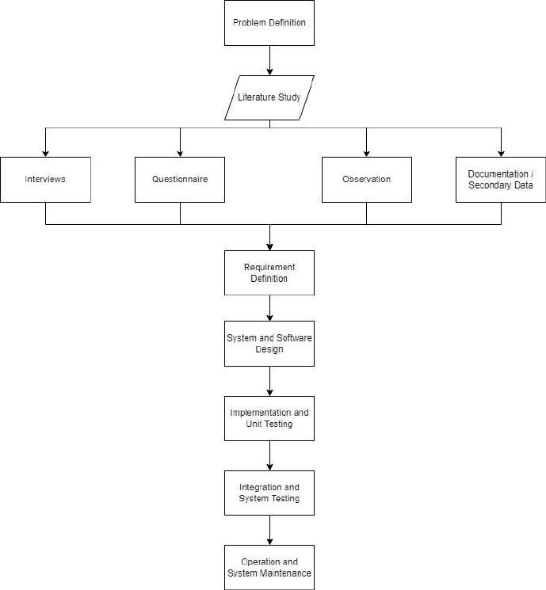

Figure 1,Research phases

Data collection techniques are determined by the setting and participants as well as the type of data to be collected. This study collects data with the following techniques:

1. The literature review is carried out by reading and studying the GMIM Church Order and the GMIM Treasury Supervision and Governance Service Guidelines as well as books or literature related to research.
2. Observation, namely using direct observation and observation of the object under study.
3. Interviews with key persons, namely the church treasury manager and the chairman of the Church Treasury Supervisory Commission (KPPJ) in order to explore and better understand the cash receipts and disbursements system and the problems and constraints faced.
4. Questionnaires on the person in charge of finance in the church groups, categorical commissions and church employees.
5. Documentation through research on existing official documents to get an accurate picture of the current data flow and data processing.

The development of system application using the Waterfall method. It’s called the waterfall method is often called the classic life cycle, where it describes a systematic and sequential approach to software development, starting with the specification of user requirements and then continuing through the planning stages, modelling, construction, and delivery of the system to customers/users (deployment), which ends with support for the complete software produced (Pressman, 2012).

Following are the stages of explanation of the Waterfall Method:

1. System Analysis Phases

Stages of system analysis carried out several processes to identify problems that occur and study the needs that will exist in software development in this study.

1. System Design Phases

The system design carried out in this study is divided into several processes, namely:

1. Database design. At this stage, the schema and relation diagrams along with the table structure are formed based on the results of the data analysis carried out.
2. Software architectural design. At this stage, the menu structure, software interfaces, messages, and semantic networks used in the system are formed.
3. Procedural design. At this stage, the identification of the process flow that will be adopted into the software to be built is carried out.
4. System Implementation Phases

After analysing and designing the software to be built, the next step is to implement these results on the object of research, with the hope that the information system software that has been made works properly and the objectives of the research can be achieved.

1. System Testing Phases

Phase of testing this system, the author evaluates the performance of the system to see the weaknesses and strengths of the software. If there are errors or omissions, the author can make improvements.

1. System Evaluation Phases

The evaluation stage is carried out to see whether the designed application is running well and is in accordance with existing needs.

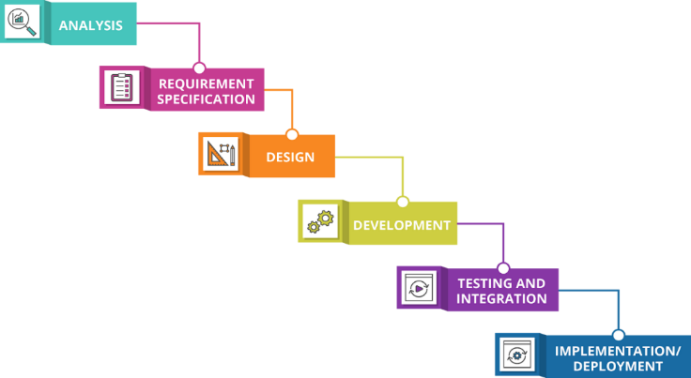

Figure 2, Waterfall Method

RESULTS AND DISCUSSION

GMIM Bethesda Tatelu as it previously mentioned, has 23 Special Servants, namely: 1 Pastor as Chair of the Congregational Council Working Body (BPMJ), 1 Congregational Pastor, 21 Elders/Chairmen, 21 Shamas/Deacons and there are 8 Church Groups and 180 Families. It organizes by the Congregational Council Working Body (BPMJ) which compiles plans and the realization of church activities including accounting activities that provide church financial reports based on the GMIM Treasury Supervision and Governance Service Manual. The financial sources of the Bethesda Tatelu GMIM Congregation come from regular worship offerings, congregational thanksgiving offerings, donors and income from government groups. The fund management in the church are:

1. Chairman and Treasurer of BPMJ
2. All Deacons
3. Chairman and Assistant Treasurer of the Categorical Service Commission; Chairperson and Assistant Treasurer of the Elderly Services Group
4. Committee formed by BPMJ

What is meant by the GMIM Treasury (GMIM Synod Church Administration, 2021) are all assets belonging to GMIM in the form of money, securities and movable goods managed by the Congregation, Region and Synod to fulfill their calling. GMIM's treasury records use the cash basis method. The treasurer will record a transaction if it relates to cash flows, whether cash in or cash out. Therefore, the accounting information system used in this study is a cash receipts accounting system and a cash disbursement accounting system. The accounting information system has maintained bookkeeping using the General Cash Book accompanied by Proof of Cash Out (BKK). BKK is made using serial numbers. Based on the data collected and interviews with the Congregational Treasurer, the Head of the BPMJ, the Chair of the Treasury Supervision Commission and church employees, an overview of the cash receipts and disbursements system currently in effect in the church is obtained. The results of the evaluation of its accounting information system:

1. There is no Subsidiary Cash Book.

Regulation on the Treasury Chapter IV Article 13 paragraph 3 (Order of the GMIM Synod Church, 2021) states that in addition to the General Cash Book, Treasurers at all levels are required to use a Subsidiary Cash Book. The Subsidiary Cash Book is used to find out the balance of each line item. Information obtained from the Subsidiary Cash Book is used to evaluate the targets of each budget item set in the Congregation's Budget and Revenue (ABP) and to assist in decision making.

1. Proof of Cash Income (BKM) has not been made

The church's income comes mostly from congregational offerings. Centralized offerings are deposited using the Column Deposit form if the offering comes from the Column. If the offering comes from BIPRA worship, then the BIPRA Worship Offerings Deposit List form is used. This centralization must be deposited to the Congregation's Treasurer every week (GMIM Synod Church Administration, 2021). Limited time and energy make the Treasurer often skip making BKM. This is an obstacle to trace the number of deposits that have been deposited. So far, the basis for recording receipts is seen from the Group Church form and the all-ages type of community services (BIPRA) Offering Deposit Form.

1. No Bank Book yet

Fund in GMIM, both in congregations, regions and Synods cannot be loaned to anyone and for security reasons all funds are kept in banks (GMIM Synod Church Administration, 2021). The amount of funds in question appears in the bank book and cash book, both in the congregation, region and synod, there is petty cash and is regulated by the congregation and the institution.

1. Fill in the form manually

Several times, reading or recording errors were come upon because the numbers written on the form were not clear. Example: The deacon and assistant treasurer fill out the Proof of deposit form by hand. The number 5 can be read as 2 or vice versa. At the time of supervision by the Congregational Treasury Supervisory Commission (KPPJ) it became a problem because the amount was different from the physical cash.

1. No Inventory Book yet

The GMIM treasury includes both movable and immovable goods. All assets belonging to GMIM are the responsibility of the Synod Assembly Working Body. Its management can be entrusted to the Council of Congregational Workers Body (BPMJ). Regulation on the Treasury Chapter IV Article 13 paragraphs 5 and 6 (GMIM Synod Church Order, 2021) requires administrative management of GMIM's inventory.

1. Inadequate internal control

Officially, the treasurer is in charge of and fully responsible for the management of the church treasury, including financial recording and reporting. In practice this is difficult to do because the church treasurer does not work entirely for the church. The treasurer is elected by the congregation through the selection of special ministers and then re-elected by the special ministers from each column. The treasurer's job is more of a ministry because it is often found that the treasurer of the congregation gets a modest reward (honor) from the church. Church employees are more often in church offices to do administrative work including receiving centralization and recording church revenues and expenses.

Based on the evaluation of the existing accounting information system, a reconstruction of the cash receipts and disbursements system is a need for the Bethesda Tatelu GMIM Congregation. The reconstruction was carried out according to the rules set out in the Church Administration and the GMIM Treasury Supervision and Governance Service Guidelines. In addition, elements of internal control are also implemented by taking into account the three principles of accounting information system design, namely: safe, fast and inexpensive.

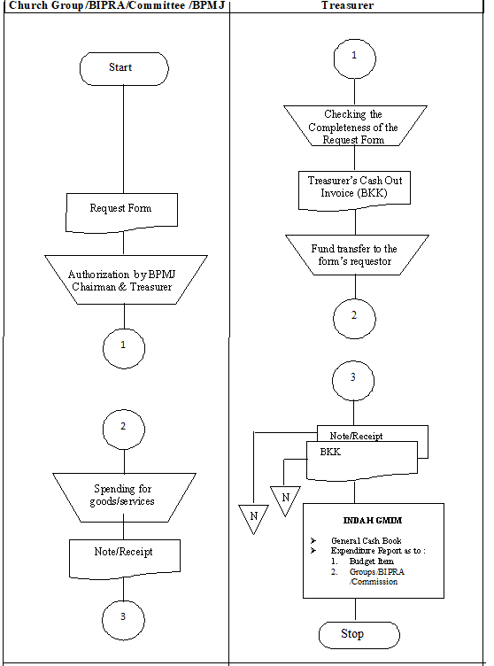

Figure 3, Cash Spending System Reconstruction’s Flow Chart

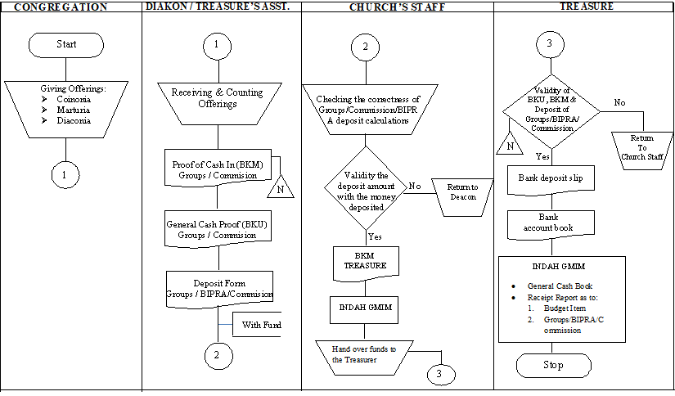

*Figure 4, Flowchart of the Cash Disbursement System in the GMIM Bethesda’s*

Later the reconstruction, the accounting information system was created in an application called GMIM Treasury Information (INDAH). This application is designed to be used by users without an accounting education background. The inputted data will be processed by the Indah GMIM application so as to produce reports according to the needs of decision makers. Users are divided into 3 levels, namely: Administrator, User and Guest. Each level has a defined authority. The admin function is held by the church treasurer as the person in charge of the church treasury, which can add users and budget items. In addition, the admin can revise what has been inputted by the User. The user is in charge of inputting data according to the existing evidence while the Guest can be given to the Assistant Treasurer who will make a deposit or request for funds.

Following is the screenshots of the application :

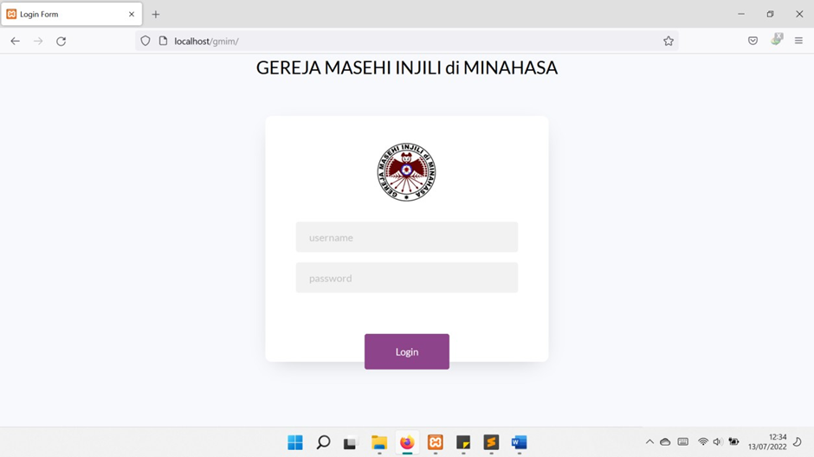

Figure 5, Login Page

Login process will directing to the type of user and authorization as follows.

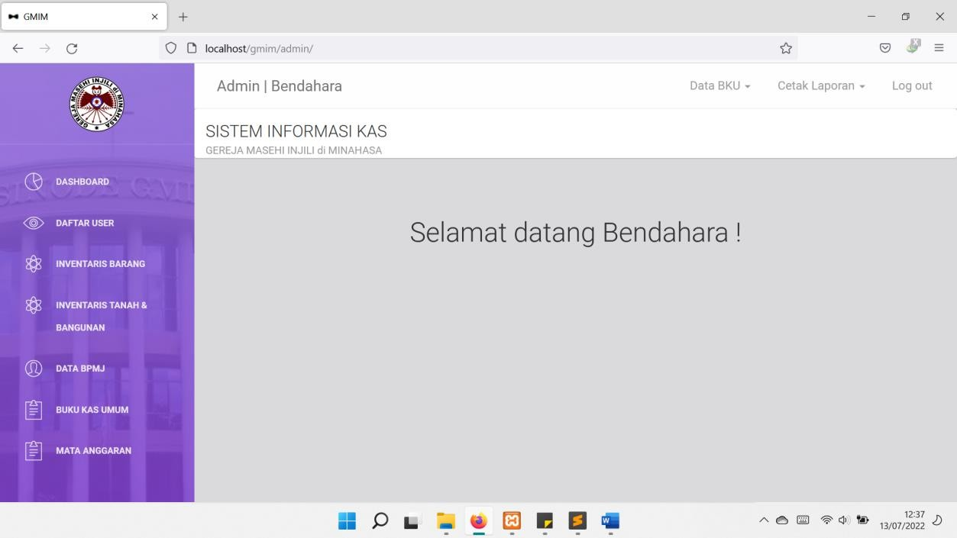

Figure 6, Administrator's Page

Treasurer serves as Administrator of the system. It’s authorized to:

* + Manage every account that is allowed to log into the system
  + Manage existing inventory data
  + Manage land and building inventory data
  + Manage BPMJ data
  + Manage General Cash Book
  + Managing Budget Items
  + Print Proof of Receipt, Payment Proof, Column Deposit, Request Note, Congregational Budget and Income (ABP)
  + Editing data input error
  + Manage application users either as User or Guest
  + Fill out and print the Bank Book

Following of the User’s page

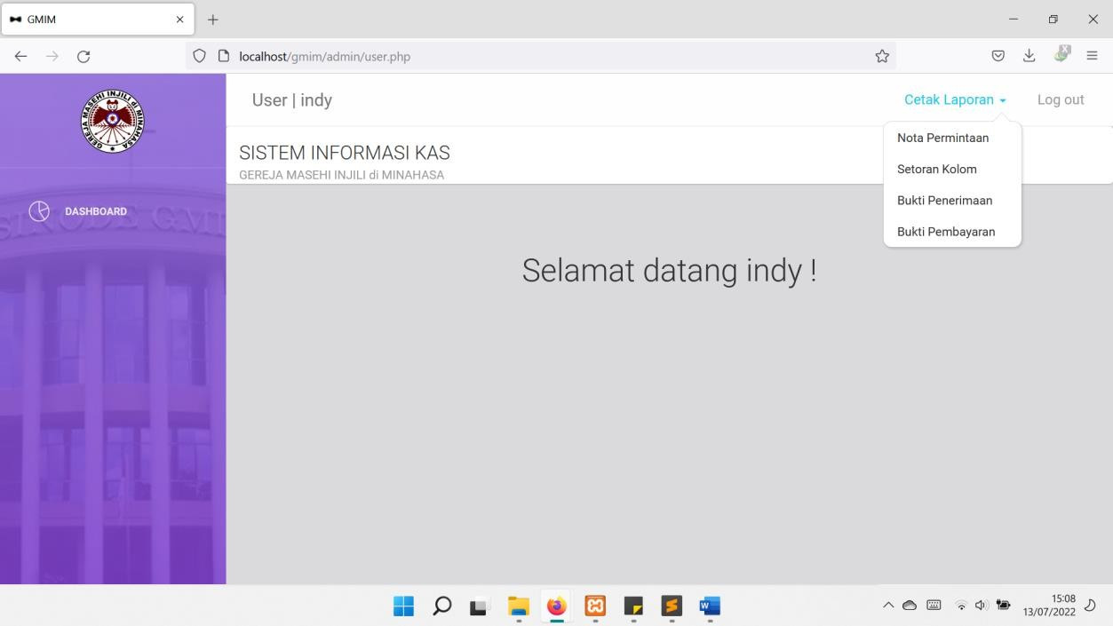

Figure 7, User's Page

Users authorized to:

* + Manage land and building inventory data
  + Manage BPMJ data
  + Manage General Cash Book
  + Print Proof of Receipt, Payment Proof, Column Deposit, Request Note, Congregational Budget and Income (ABP)
  + Fill out and print the Bank Book

Guest is not included in the church treasury system accounting but has an interest in depositing and requesting funds. Access to the application is restricted to:

* + Print Request Note
  + Printing Column Deposit
  + Printing Receipts
  + Print Proof of Payment

**CONCLUSION**

Non-profit organizations operate based on donations or gifts from parties who believe that the organization uses the funds provided in a transparent and responsible manner. This requires timely and reliable financial reports. GMIM is a non-profit organization that is oriented to church services and raises funds to support the ministry. Church financial reporting often experiences problems due to limited resources.

The Indah GMIM application is based on the reconstruction of the cash receipts and disbursements system. This reconstruction follows the rules made by the GMIM Synod so that it can be used for all GMIM congregations spread across the country and abroad. This application makes it easy for users to generate financial reports with different backgrounds. Processing time can be faster by using the application. Indah GMIM can be used by several devices in one online congregation and helps control the function of the treasurer.

In this application Admin is given to the church treasurer and the chairman of the BPMJ as the person in charge of the church treasury, which can add users and budget items. In addition, the admin can revise what has been inputted by the user. The user is in charge of inputting data according to the existing evidence while the Guest can be given to the Assistant Treasurer who will make a deposit or request for funds. Proof of deposit, request notes and other forms can be filled and printed thereby reducing the rate of writing errors.

Application users are divided into 3 levels for control purposes. The data that has been inputted by the user cannot be changed without the knowledge of the Admin. The admin is in charge of the church treasury. Every week the financial reports are announced to the congregation through the church newsletter. Every month the financial statements are reported and evaluated by the Assembly. Periodically, every six months the treasurer will be checked by KPPJ. The results of the examination are submitted to the Congregational Council Session.

Subsidiary cash book is a book that must be made but due to limited resources this book was missed. Admin and User can print cash book The Indah GMIM application helps the treasurer to record, control and evaluate financial reports. Receipt and expense data is only inputted once by the Admin and User which will affect the Subsidiary Cash Book. Reports can be printed according to budget items/dates/columns as needed.

Inventory lists are often overlooked in nonprofits. In fact, this data reflects the assets of the organization. The inventory list can be filled through the Indah application. If there is a change in church assets it can be immediately recorded and updated. So that at the time of monitoring the inventory list is in accordance with the circumstances.

Suggestions for the GMIM Synod Assembly Working Body (BPMS) to be able to update the treasury guidelines and rules in accordance with applicable accounting standards. Future research can reconstruct the current supervisory service guidelines by adding financial reports based on ISAK 35 and complementing the existing budget items.

**REFRENCES**

Fitriyanti, D. A. (2021). Desain Sistem Informasi Akuntansi Penerimaan Dan Pengeluaran Kas Pada Usaha Kecil Dan Menengah (Umkm) Wingko Babat Diva (Doctoral dissertation, Universitas Muhammadiyah Malang).

Ikatan Akuntan Indonesia. Revisi 2015. Pernyataan Standar Akuntansi Keuangan 1 tentang Penyajian Laporan Keuangan.

Ikatan Akuntan Indonesia. Revisi 2015. Pernyataan Standar Akuntansi Keuangan 45 tentang Organisasi Nir Laba

Hall, Ja. (2011). Sistem Informasi Akuntansi, Edisi Keempat, Salemba Empat, Jakarta.

Hamidu, Novia P. 2013. Pengaruh Kinerja Keuangan Terhadap Pertumbuhan Laba.

Kieso, Donald E., Jerry J. Weygandt dan Terry D. Warfield. (2011). Intermediate Accounting, Vol. 1. IFRS Edition. John Wiley & Sons.

Krismiaji. (2015). Sistem Informasi Akuntansi, Edisi Keempat, Perusahaan YKPN, Yogyakarta.

Marentek, B., Lumenta, A. S., & Lantang, O. A. (2017). Rancang Bangun Web Service Sistem Informasi Keuangan GMIM Wilayah Tomohon 3. Jurnal Teknik Informatika, 12(1).

Mulyadi, (2016). Sistem Akuntansi, Edisi 4, Salemba Empat.

Rosidi, M., & Manurung, N. (2021). Analisis Penerapan PSAK 45 dalam Pembuatan Laporan Keuangan di Gereja HKBP Cinere Tahun 2020. GOODWILL, 3(2 Desember), 372-379.

Sinode GMIM, Pedoman Pelayanan Pengawasan dan Tata Kelola Perbendaharaan GMIM (2018)

Sinode GMIM, Tata Gereja GMIM (2021)